7.63: The skier is subject to both gravity and a normal force; it is the normal force that causes her to go in a circle, and when she leaves the hill, the normal force vanishes. The vanishing of the normal force is the condition that determines when she will leave the hill. As the normal force approaches zero, the necessary (inward) radial force is the radial component of gravity, or 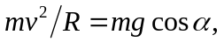 where R is the radius of the snowball. The speed is found from conservation of energy; at an angle , she has descended a vertical distance 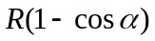, so 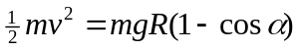, or 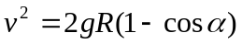. Using this in the previous relation gives 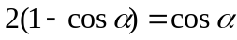, or 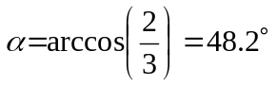. This result does not depend on the skier’s mass, the radius of the snowball, or g.

